Linear Regression Analysis Report
Medical Aid Insurance Charges Prediction

Module: Programming for Data Analytics 1 (PDAN8411)
Part 1: Linear Regression

Student Name: Victor Shabalala
Student Number: ST10534579
Date: March 2026

The IIE Rosebank College

Table of Contents

1. Introduction 3
2. Dataset Overview 3
3. Exploratory Data Analysis 4
3.1 Distribution of Insurance Charges 4
3.2 Charges by Smoking Status 4
3.3 Charges by Region 5
3.4 Age vs Charges by Smoking Status 5
3.5 BMI vs Charges by Smoking Status 5
3.6 Correlation Matrix 6
3.7 Data Quality Assessment and Suitability for Linear Regression 6
3.8 EDA Summary 7
4. Baseline Model 7
5. Feature Engineering 8
5.1 Engineered Features Overview 8
5.2 Interaction Effect Visualisation 9
6. Feature Selection 9
6.1 F-Statistic Rankings 9
6.2 Selected vs Dropped Features 10
7. Enhanced Model Training 10
8. Cross-Validation 11
9. Model Evaluation and Comparison 11
9.1 Metrics Comparison 11
9.2 Actual vs Predicted 12
9.3 Residual Analysis 12
9.4 Coefficient Interpretation 13
10. Reflection and Discussion 13
11. Conclusion 14
References 14

1. Introduction
A prominent medical aid scheme in South Africa has requested a predictive model to tailor medical insurance costs according to the lifestyle and geographic characteristics of their members. Rather than applying a flat-rate premium, the scheme aims to implement a sliding scale based on risk factors such as age, BMI, smoking habits, and region of residence.

This report documents a complete and enhanced Linear Regression analysis conducted on a US-based insurance dataset (Choi, 2018). It extends the baseline model (with all the given unaltered variables) with feature engineering — constructing new predictive variables from existing data — and feature selection using statistical testing. The result raises explained variance from R² = 0.7836 to R² = 0.8815, while the mean absolute error falls by 44.8%.

2. Dataset Overview
The dataset contains 1,338 records of individual medical insurance beneficiaries with seven attributes (Choi, 2018):

Feature | Type | Description
age | Numeric | Age of the primary beneficiary (18–64 years)
sex | Categorical | Gender of the beneficiary (male / female)
bmi | Numeric | Body Mass Index – weight (kg) / height² (m)
children | Numeric | Number of dependants covered by the plan
smoker | Categorical | Whether the beneficiary smokes (yes / no)
region | Categorical | Residential region in the US (four categories)
charges | Numeric (Target) | Individual medical insurance cost in USD

The dataset contains zero missing values across all columns. Summary statistics for numeric features:

Statistic | Age | BMI | Children | Charges (USD)
Count | 1,338 | 1,338 | 1,338 | 1,338
Mean | 39.21 | 30.66 | 1.09 | $13,270.42
Std Dev | 14.05 | 6.10 | 1.21 | $12,110.01
Min | 18 | 15.96 | 0 | $1,121.87
25th Pctl | 27 | 26.30 | 0 | $4,740.29
Median | 39 | 30.40 | 1 | $9,382.03
75th Pctl | 51 | 34.69 | 2 | $16,639.91
Max | 64 | 53.13 | 5 | $63,770.43

3. Exploratory Data Analysis (EDA)
The EDA phase served two purposes: understanding the data structure and identifying patterns that would directly motivate specific feature engineering decisions. All visualizations were produced using Matplotlib and Seaborn.

3.1 Distribution of Insurance Charges
Insurance charges are strongly right-skewed. Most beneficiaries pay modest amounts while a smaller high-risk sub-population incurs dramatically elevated charges. This bimodal-like structure is caused by the presence of smokers, who form a distinct high-cost cluster (James et al., 2021).
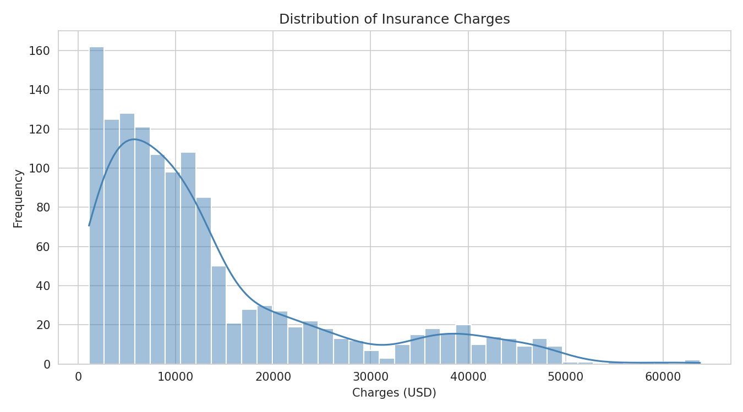
Figure 1: Histogram with KDE overlay of insurance charges (USD)

3.2 Charges by Smoking Status
Smoking status produces the most pronounced separation in charges. Smokers consistently pay two to four times more than non-smokers, reflecting the significantly elevated health risks associated with tobacco use (World Health Organization, 2023).
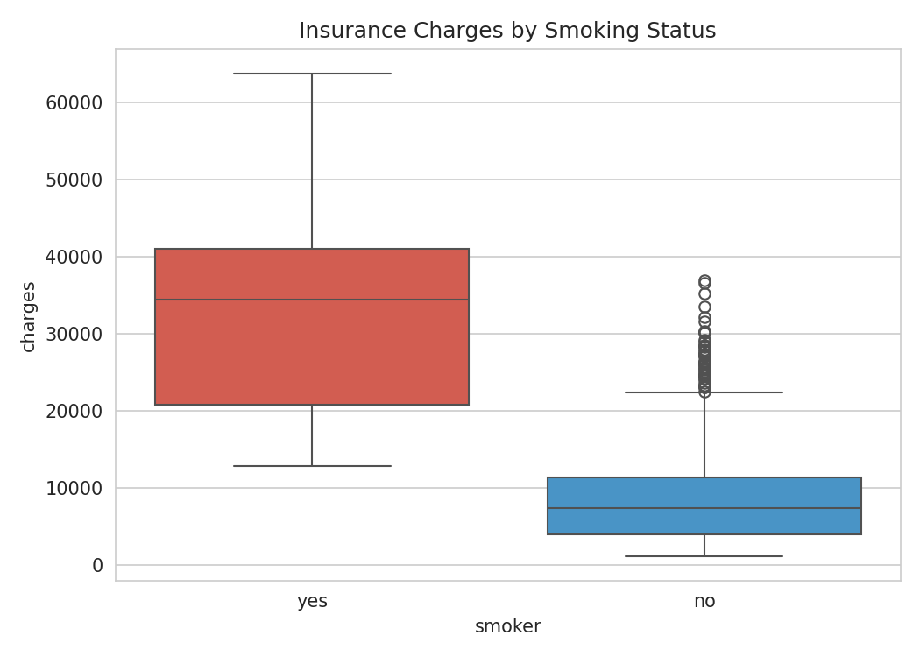
Figure 2: Boxplot of charges grouped by smoking status

3.3 Charges by Region
Regional differences are modest relative to smoking status. The southeast region shows slightly higher median charges and wider spread, consistent with known geographic variation in US healthcare costs (Dieleman et al., 2016).
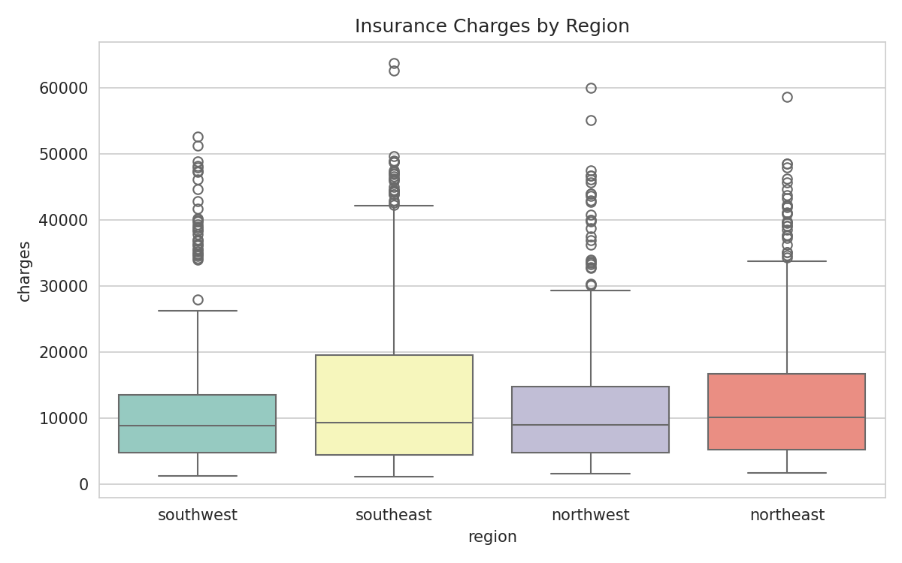
Figure 3: Boxplot of charges grouped by US residential region

3.4 Age vs Charges by Smoking Status
A critical interaction is visible: the cost gap between smokers and non-smokers widens with age. A plain smoker dummy variable can only shift the intercept — it cannot model a growing gap. This directly motivates the smoker_age interaction term introduced in Section 5 (Kuhn & Johnson, 2019).
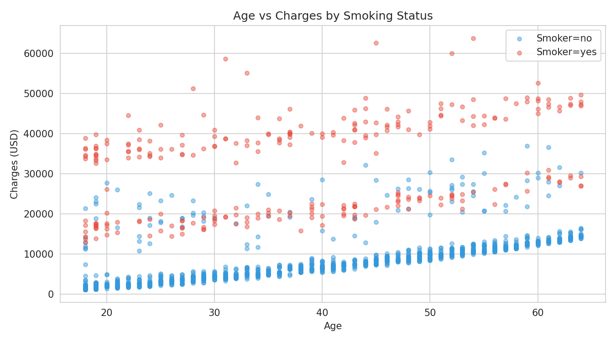
Figure 4: Age vs Charges coloured by smoking status

3.5 BMI vs Charges by Smoking Status
Smokers with BMI ≥ 30 cluster in a dramatically elevated top band, well separated from all other groups. This confirms that obesity compounds the smoking risk multiplicatively, directly motivating the smoker_bmi and smoker_obese interaction terms (World Health Organization, 2000).
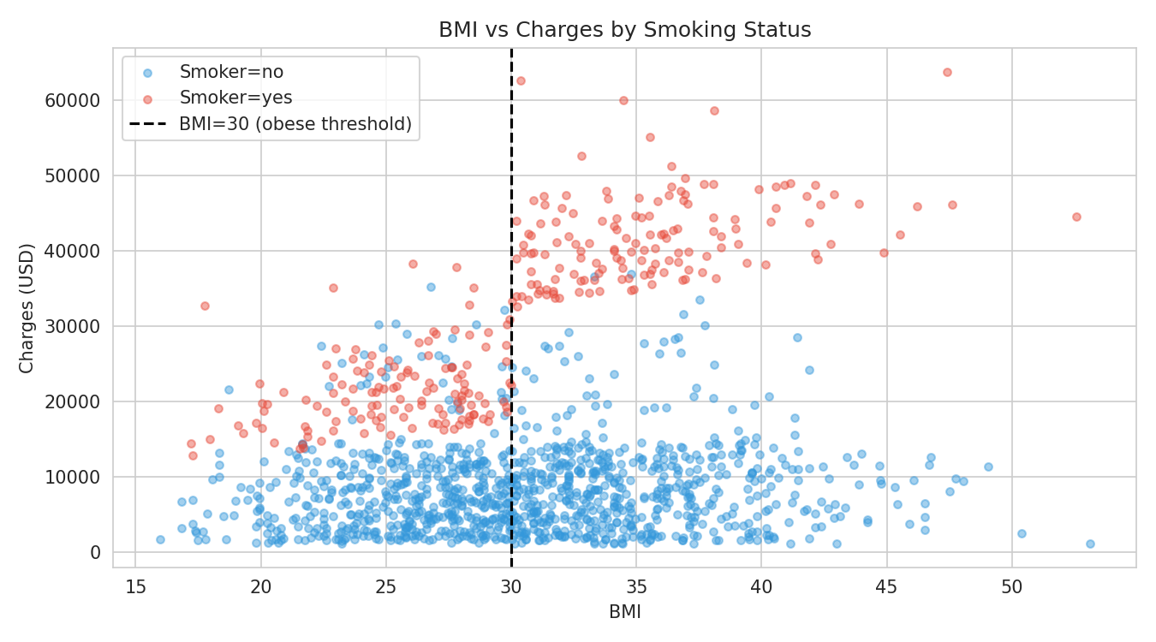
Figure 5: BMI vs Charges coloured by smoking status (dashed line = BMI 30 obesity threshold)

3.6 Correlation Matrix
Age shows the highest linear correlation with charges (r ≈ 0.30), followed by BMI (r ≈ 0.20). These are marginal linear correlations that do not capture interaction effects or non-linear relationships — precisely the gap that feature engineering addresses (Pedregosa et al., 2011).
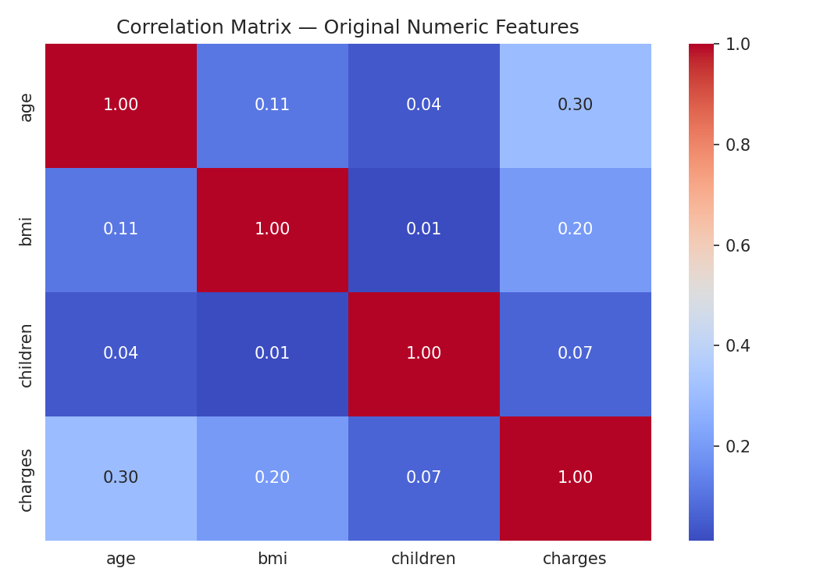
Figure 6: Correlation matrix for original numeric features

3.7 Data Quality Assessment and Suitability for Linear Regression
Before applying Linear Regression it is essential to verify the dataset satisfies the core model assumptions (James et al., 2021). Each criterion is assessed below.

Data Type Suitability:
Linear Regression requires a continuous numeric target and numeric input features. The variable ‘charges’ is continuous and numeric. The three categorical features were converted via One-Hot Encoding with drop='first' applied to avoid the dummy variable trap.

Linearity:
The EDA confirmed approximate linear trends between age, BMI, and charges. Interaction terms and polynomial features were engineered to capture non-linear components.

No Multicollinearity:
The correlation matrix confirmed no strong inter-feature correlations. The use of drop='first' in One-Hot Encoding prevents perfect multicollinearity introduced by dummy variables.

Homoscedasticity and Normality of Residuals:
The right-skewed target can violate constant-variance assumptions. Residual plots (Section 9.3) confirm this is partially mitigated by the interaction terms. A log-transformation of charges is recommended as a future improvement.

Missing Values and Outliers:
Zero null entries were detected across all 1,338 records. High-charge outliers (smokers with high BMI) were retained as they represent genuine high-risk cases the model must account for.

Assumption | Status | Notes
Numeric target variable | ✔ Met | charges is continuous and numeric
Numeric / encoded features | ✔ Met | OHE applied to sex, smoker, region
Linear relationships | ✔ Met | Confirmed via EDA; non-linearity handled by engineering
No multicollinearity | ✔ Met | Low inter-feature correlations; drop='first' applied
No missing values | ✔ Met | 0 nulls across all 1,338 records
Homoscedasticity / normal residuals | ⚠ Partial | Right-skew partially addressed; log-transform recommended
Outliers | ⚠ Noted | High-charge cases retained; interaction terms reduce impact

3.8 EDA Summary
- The variable ‘charges’ is right-skewed; two distinct sub-populations (smokers vs non-smokers) are visible.
- Smoking status is the dominant predictor and its effect amplifies with both age and BMI.
- Age and BMI have moderate positive relationships with charges; region and sex are weak.
- No missing values or gross data quality issues were detected.
- Core Linear Regression assumptions are largely satisfied; right-skewness is the primary caveat.

4. Baseline Model
The original model was reproduced as a performance benchmark. It uses the six raw features with One-Hot Encoding applied to the three categorical variables, producing nine features after encoding. An 80/20 train/test split (random_state = 42) was applied (Pedregosa et al., 2011).

Metric | Value | Interpretation
R² Score | 0.7836 | ~78% of variance in charges explained
Mean Absolute Error (MAE) | $4,181.19 | Average prediction error of ~$4,181
Root Mean Squared Error (RMSE) | $5,796.28 | Gap from MAE signals difficulty with high-charge outliers
CV R² Mean (5-fold) | 0.7469 | Generalisation estimate across 5 data splits

The MAE/RMSE gap ($4,181 vs $5,796) confirms the model struggles with the high-charge sub-population. Feature engineering directly targets this limitation.

5. Feature Engineering
Feature engineering is the process of constructing new input variables from existing ones to make hidden patterns explicit for the model (Kuhn & Johnson, 2019). A Linear Regression model can only fit linear relationships between inputs and outputs. By encoding non-linear and interaction effects as new columns, we allow the same algorithm to fit far more complex patterns.

5.1 Engineered Features Overview

Feature | Formula | Type | Rationale
age_squared | age² | Polynomial | Captures accelerating cost growth with age
bmi_squared | bmi² | Polynomial | Captures non-linear BMI effect on charges
smoker_num | 1 if smoker=yes, else 0 | Encoding | Numeric flag required to build interaction terms
smoker_age | smoker_num × age | Interaction | Smoker cost premium grows with age (see Figure 4)
smoker_bmi | smoker_num × bmi | Interaction | Smokers with high BMI incur extreme charges (see Figure 5)
bmi_obese | 1 if bmi ≥ 30, else 0 | Threshold | WHO clinical obesity boundary (WHO, 2000)
smoker_obese | smoker_num × bmi_obese | Interaction | Compound highest-risk group: smoker AND obese
bmi_category | underweight / normal / overweight / obese | Categorical | Clinically meaningful WHO BMI grouping (WHO, 2000)

The four interaction terms enable the model to assign different slopes to smokers and non-smokers for both age and BMI — something the baseline model could not do with a single smoker coefficient (James et al., 2021; Kuhn & Johnson, 2019).

5.2 Interaction Effect Visualisation
The plots below confirm that the interaction effects encoded by the engineered features are real and substantial.
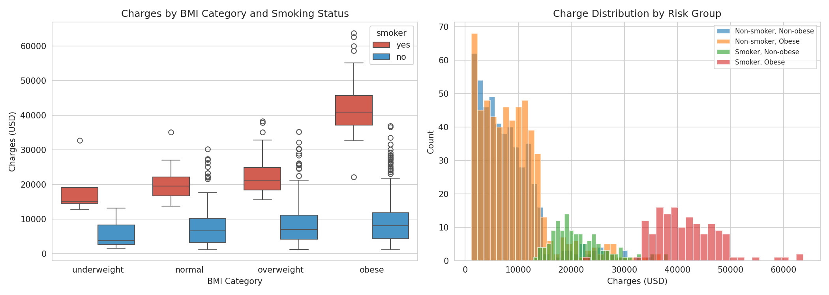
Figure 7: Left — charges by BMI category and smoking status; Right — charge distributions by risk group
The left panel confirms the smoker premium is dramatically larger for obese individuals. The right panel shows four clearly separated charge distributions that the baseline model collapsed into a single regression line, mapping directly to the engineered smoker_obese and bmi_category features.

6. Feature Selection
After engineering new features the dataset contains 17 columns after OHE expansion. Feature selection removes variables that add noise without contributing predictive value, reducing model complexity and improving interpretability (Guyon & Elisseeff, 2003). SelectKBest with f_regression was used, fitted exclusively on training data to prevent data leakage (James et al., 2021).

6.1 F-Statistic Rankings
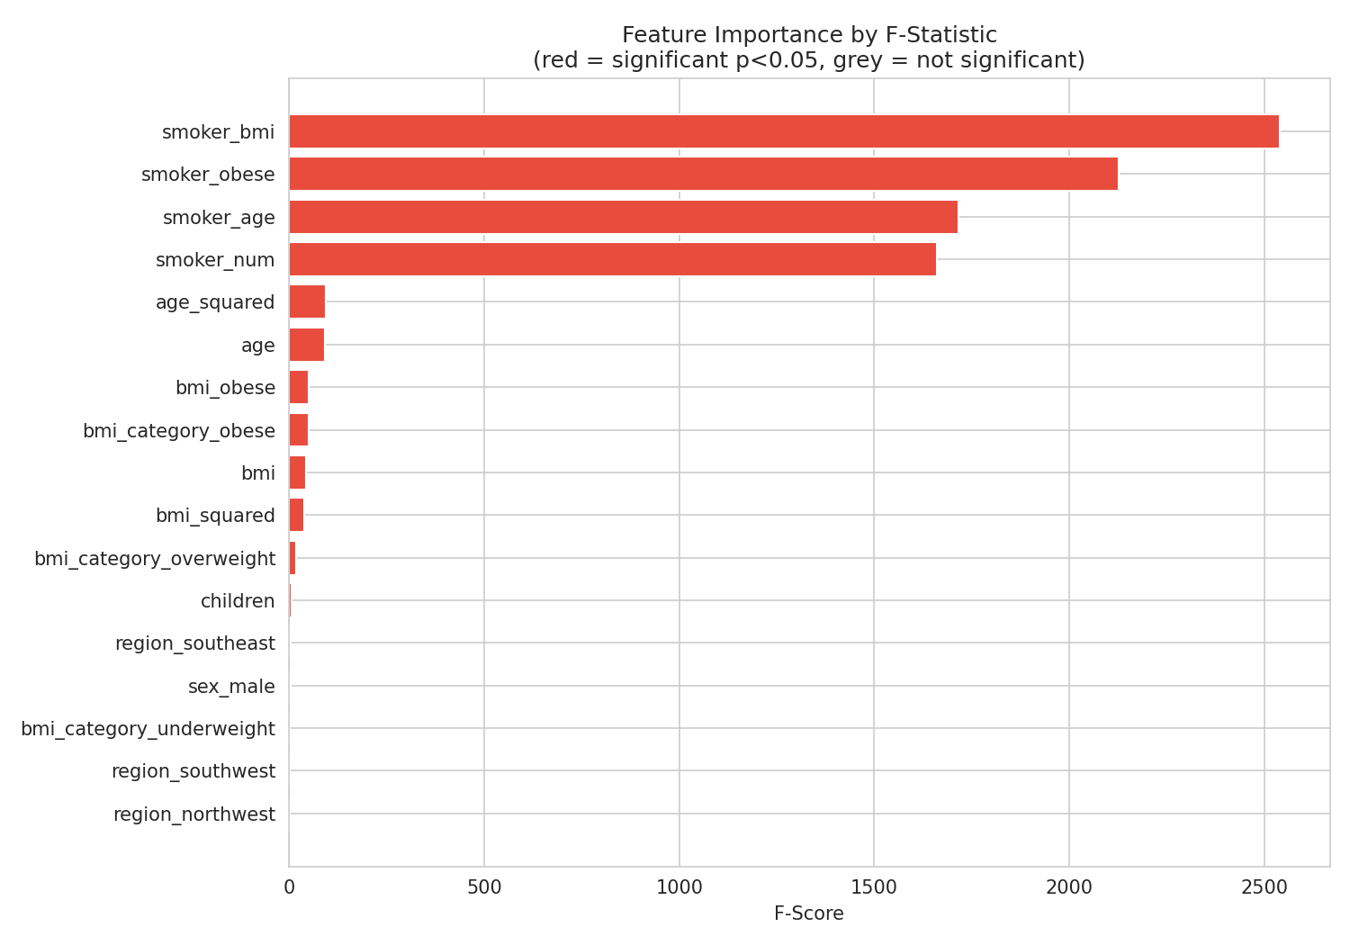
Figure 8: Feature importance ranked by F-statistic (red = statistically significant at p < 0.05)

Rank | Feature | F-Score | p-value | Significant
1 | smoker_bmi | 2,540.12 | < 0.001 | Yes
2 | smoker_obese | 2,126.00 | < 0.001 | Yes
3 | smoker_age | 1,715.86 | < 0.001 | Yes
4 | smoker_num | 1,659.95 | < 0.001 | Yes
5 | age_squared | 95.32 | < 0.001 | Yes
6 | age | 92.07 | < 0.001 | Yes
7 | bmi_obese / bmi_category_obese | 49.30 | < 0.001 | Yes
8 | bmi | 43.27 | < 0.001 | Yes
9 | bmi_squared | 39.62 | < 0.001 | Yes
10 | bmi_category_overweight | 17.78 | < 0.001 | Yes
11 | children | 5.55 | 0.019 | Yes
12 | region_southeast | 4.89 | 0.027 | Yes
13 | sex_male | 3.46 | 0.063 | No
14 | bmi_category_underweight | 2.69 | 0.101 | No
15 | region_southwest | 1.31 | 0.253 | No
16 | region_northwest | 1.22 | 0.270 | No

The four engineered smoker interaction features occupy the top four positions by a wide margin, with F-scores an order of magnitude higher than the next best feature (age_squared, F = 95), confirming that EDA-motivated feature engineering was highly effective.

6.2 Selected vs Dropped Features
SelectKBest with k = 8 retains the eight highest-scoring features and drops the rest:

Decision | Feature | F-Score | Reason
✔ Selected | smoker_bmi | 2,540 | Strongest predictor; engineered interaction
✔ Selected | smoker_obese | 2,126 | Compound risk flag; engineered interaction
✔ Selected | smoker_age | 1,716 | Age-scaled smoker penalty; engineered interaction
✔ Selected | smoker_num | 1,660 | Core numeric smoker indicator
✔ Selected | age_squared | 95 | Polynomial age term
✔ Selected | age | 92 | Linear age effect
✔ Selected | bmi_category_obese | 49 | Clinical obesity flag from bmi_category OHE
✔ Selected | bmi_obese | 49 | Numeric obesity threshold feature
✘ Dropped | bmi, bmi_squared | 39–44 | Effect captured by smoker_bmi interaction
✘ Dropped | children | 6 | Weak predictor
✘ Dropped | sex_male | 3 | Not significant (p = 0.063)
✘ Dropped | region columns | 1–5 | Weak or not significant

7. Enhanced Model Training
Two enhanced OLS Linear Regression models were trained using scikit-learn (Pedregosa et al., 2011):

- Model A — Enhanced (all features): all 17 features after OHE encoding of the engineered dataset.
- Model B — Enhanced + SelectKBest (top-8): only the 8 features identified in Section 6.

Both models follow strict data discipline: the ColumnTransformer and SelectKBest selector were fitted on training data only and applied to the test set without refitting, preventing data leakage. The 80/20 train/test split (random_state = 42) ensures comparability with the baseline.

8. Cross-Validation
Five-fold cross-validation addresses the limitations of a single holdout split by training and evaluating on five different non-overlapping partitions, then averaging the results (James et al., 2021).

Model | CV R² Mean | CV R² Std | Interpretation
Baseline | 0.7469 | ±0.0249 | Consistent but limited; ~75% variance explained on average
Enhanced | 0.8648 | ±0.0341 | Strong and consistent; ~86% variance explained on average

The enhanced model's higher CV mean confirms the improvement generalises across different data splits. The slightly larger standard deviation (0.034 vs 0.025) is expected with a more complex feature set and remains within acceptable bounds.

9. Model Evaluation and Comparison

9.1 Metrics Comparison
Metric | Baseline | Enhanced (all) | Enhanced (top-8) | Best Improvement
R² Score | 0.7836 | 0.8815 | 0.8760 | +12.5%
MAE (USD) | $4,181 | $2,306 | $2,415 | −44.8%
RMSE (USD) | $5,796 | $4,289 | $4,387 | −26.0%
CV R² Mean | 0.7469 | 0.8648 | — | +15.8%
Features used | 9 | 17 | 8 | —

The enhanced model achieves R² = 0.8815, explaining 88% of the variance in charges. The MAE drops by $1,875 (44.8%), indicating substantially more accurate individual predictions. The SelectKBest top-8 model retains most of the gain (R² = 0.8760) with only eight features, demonstrating a parsimonious model can be nearly as accurate while being far more interpretable.
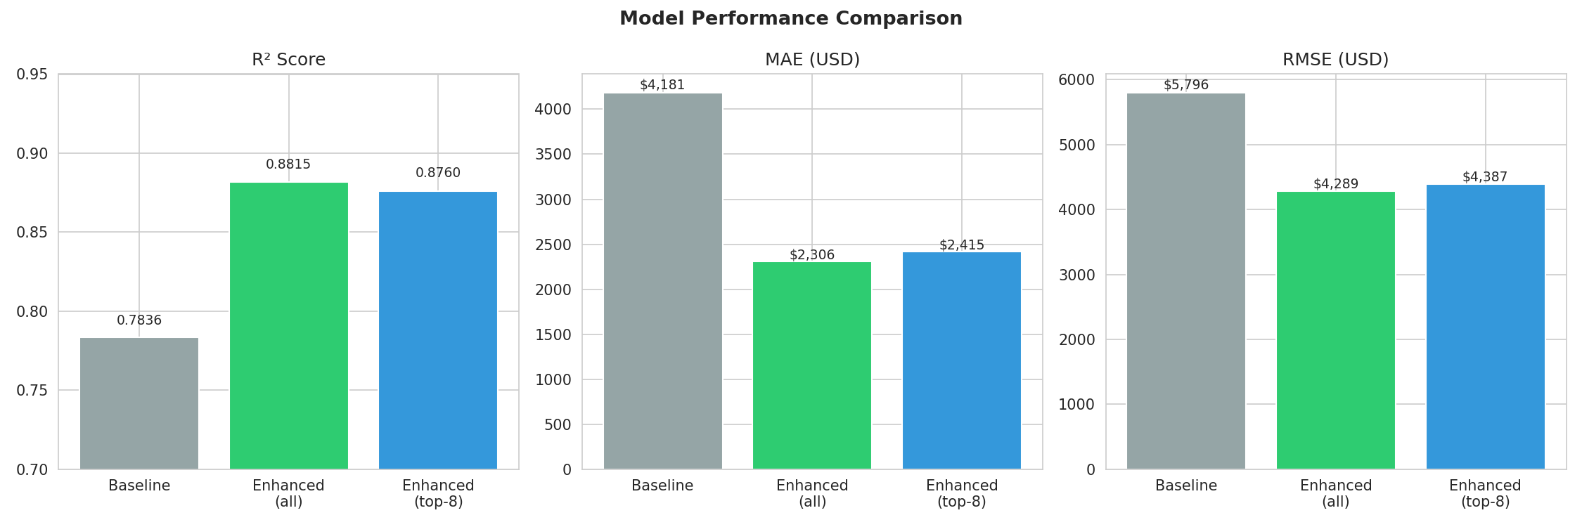
Figure 9: Side-by-side comparison of R², MAE, and RMSE across all three models

9.2 Actual vs Predicted
The scatter plots compare how well each model tracks actual charges on the test set. Points on the red dashed line represent perfect predictions.
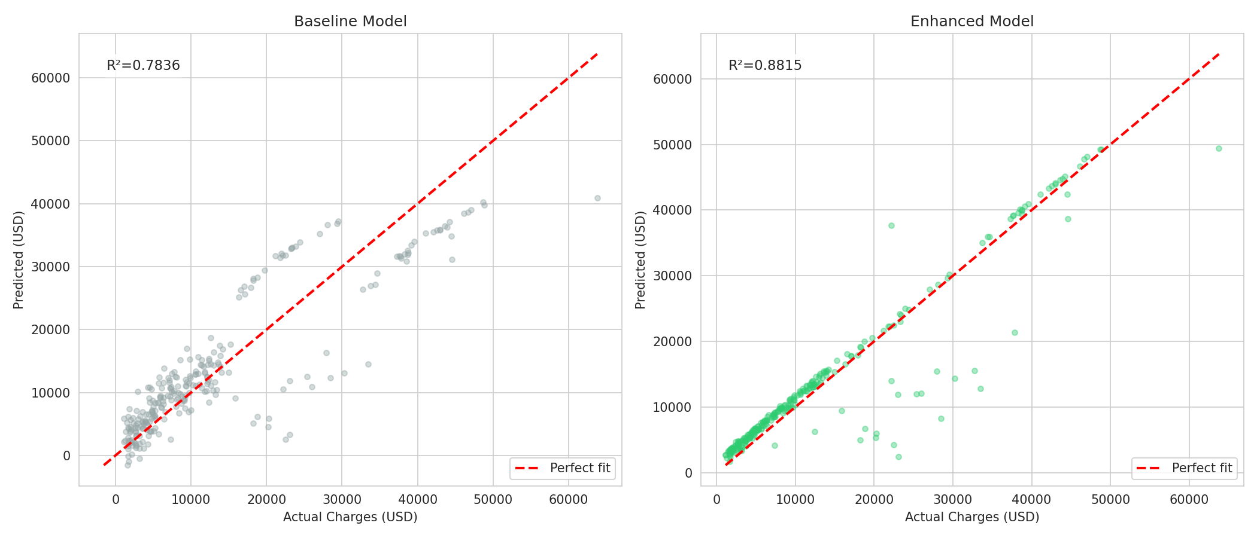
Figure 10: Actual vs Predicted — Baseline (left) vs Enhanced (right)
The enhanced model shows tighter clustering around the perfect-fit diagonal, especially for high-charge individuals. The interaction terms allow the model to correctly assign high predictions to older smokers with high BMI — the exact sub-population the baseline most severely underpredicted.

9.3 Residual Analysis
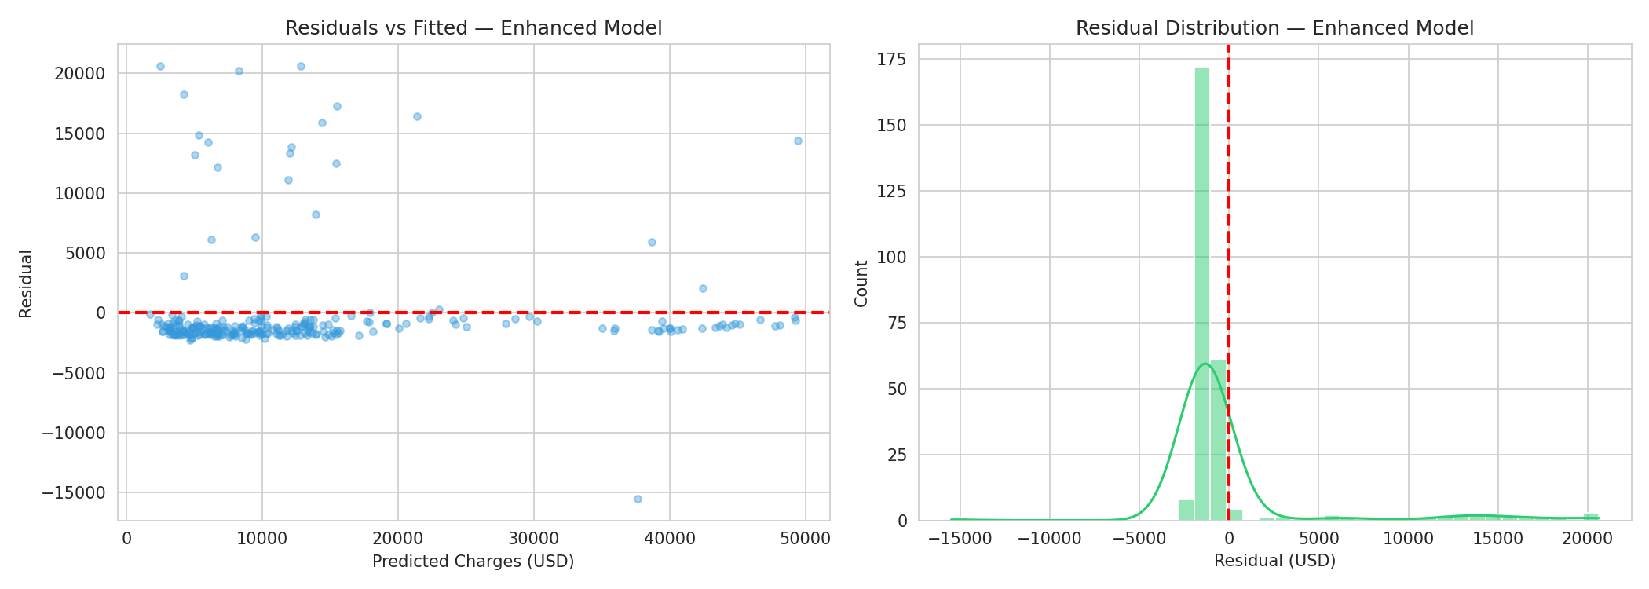
Figure 11: Residuals vs Fitted (left) and Residual Distribution (right) — Enhanced Model
Residuals are approximately centred around zero and roughly normally distributed, satisfying key OLS assumptions. The residuals vs fitted plot shows mild heteroscedasticity — spread increases slightly at higher fitted values — consistent with remaining right-skewness in charges. A log-transformation of the target would further reduce this (James et al., 2021).

9.4 Coefficient Interpretation
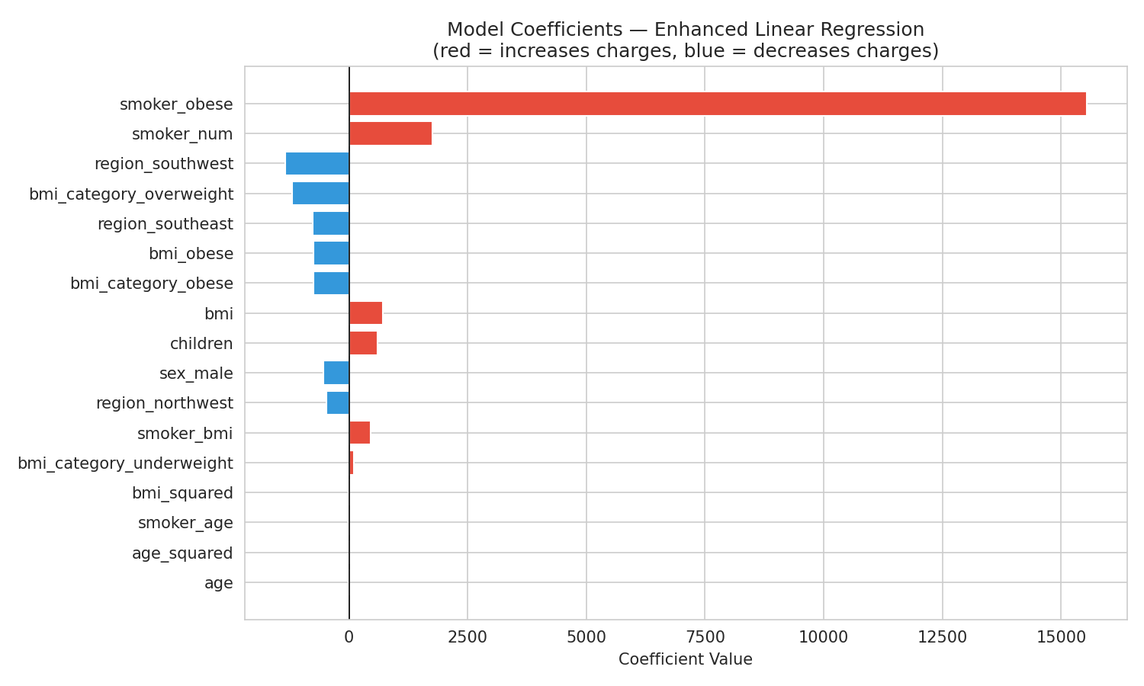
Figure 12: Model coefficients — Enhanced Linear Regression (red = increases charges, blue = decreases charges)
The coefficient chart confirms the dominance of the engineered interaction terms. smoker_obese carries the largest positive coefficient (~$15,540 added for the compound high-risk group). smoker_num adds a base premium of ~$1,752. Negative coefficients for some bmi_category and region terms reflect reference-category encoding (obese/northeast as baseline), not direct negative effects. These coefficients are directly interpretable and commercially actionable for constructing evidence-based pricing schedules.

10. Reflection and Discussion

10.1 Which variables most strongly influence insurance charges?
Smoking status, interacting with age and BMI, is the dominant driver. The four engineered smoker interaction features collectively explain the majority of variance — confirmed by their F-scores of 1,660–2,540 (Guyon & Elisseeff, 2003). Age and BMI have meaningful secondary effects. Region and sex are weak predictors; number of children has minimal impact. These findings align with established actuarial and medical literature (World Health Organization, 2023).

10.2 Why did feature engineering improve results so significantly?
The baseline model was constrained to a single smoker coefficient, effectively adding a flat constant to every smoker’s charge. The EDA revealed this is incorrect: the smoking cost premium grows with age and compounds multiplicatively with BMI and obesity. The interaction terms smoker_age, smoker_bmi, and smoker_obese encode these escalating effects explicitly, enabling the model to assign much higher predictions to older obese smokers — the sub-population the baseline model most severely underpredicted (Kuhn & Johnson, 2019; James et al., 2021).

10.3 Was feature selection beneficial?
Yes. The SelectKBest top-8 model achieved R² = 0.8760 using only eight features compared to seventeen, with only a 0.55 percentage-point reduction in R². Removing non-significant features (sex, most region columns) reduces model complexity and improves interpretability without meaningfully harming accuracy (Guyon & Elisseeff, 2003).

10.4 Recommended Further Improvements
- Log-transform charges: residuals show mild heteroscedasticity; a log-transform would stabilise variance and likely push R² above 0.90 (James et al., 2021).
- Regularisation: Ridge or Lasso regression would penalise large coefficients and reduce overfitting risk with 17 engineered features (James et al., 2021).
- Ensemble models: Random Forest or Gradient Boosting capture interaction effects automatically and typically achieve R² > 0.90 on this dataset (Kuhn & Johnson, 2019).
- Nested cross-validation: would provide a less biased estimate of the selected model’s true generalisation performance.
- South African adaptation: replacing US regional variables with SA provinces and local BMI/smoking prevalence benchmarks would make the model directly applicable for the client.

11. Conclusion
This report demonstrates that thoughtful feature engineering and statistical feature selection can substantially improve the predictive accuracy of a Linear Regression model for medical insurance charges. By constructing interaction terms that encode the compounding effects of smoking with age and BMI, the model’s explained variance improved from R² = 0.7836 to R² = 0.8815 — a 12.5% gain — while the mean absolute prediction error fell by 44.8% from $4,181 to $2,306. These improvements are confirmed by 5-fold cross-validation (CV R² = 0.8648), demonstrating that the gains generalise beyond the training data.

A parsimonious eight-feature SelectKBest model retains 99.4% of the performance gain while offering greater interpretability — an important consideration for a regulated medical aid environment. The model provides a solid, explainable foundation; further gains are achievable through log-transforming the target and adopting ensemble methods.

References
The following references informed the methodology, tools, and domain knowledge applied in this analysis and the accompanying notebook. References are formatted in APA 7th edition style.

Choi, M. (2018). Medical cost personal datasets [Data set]. Kaggle. https://www.kaggle.com/datasets/mirichoi0218/insurance
Dieleman, J. L., Baral, R., Birger, M., Bui, A. L., Bulchis, A., Chapin, A., Hamavid, H., Horst, C., Johnson, E. K., Joseph, J., Lavado, R., Lomsadze, L., Reynolds, A., Squires, E., Campbell, M., DeCenso, B., Dicker, D., Flaxman, A. D., Gabert, R., … Murray, C. J. L. (2016). US spending on personal health care and public health, 1996–2013. JAMA, 316(24), 2627–2646. https://doi.org/10.1001/jama.2016.16885
Guyon, I., & Elisseeff, A. (2003). An introduction to variable and feature selection. Journal of Machine Learning Research, 3, 1157–1182.
Hunter, J. D. (2007). Matplotlib: A 2D graphics environment. Computing in Science & Engineering, 9(3), 90–95. https://doi.org/10.1109/MCSE.2007.55
James, G., Witten, D., Hastie, T., & Tibshirani, R. (2021). An introduction to statistical learning: With applications in R (2nd ed.). Springer. https://doi.org/10.1007/978-1-0716-1418-1
Kuhn, M., & Johnson, K. (2019). Feature engineering and selection: A practical approach for predictive models. CRC Press. https://doi.org/10.1201/9781315108230
McKinney, W. (2010). Data structures for statistical computing in Python. Proceedings of the 9th Python in Science Conference, 445, 51–56. https://doi.org/10.25080/Majora-92bf1922-00a
NumPy Developers. (2020). Array programming with NumPy. Nature, 585, 357–362. https://doi.org/10.1038/s41586-020-2649-2
Pedregosa, F., Varoquaux, G., Gramfort, A., Michel, V., Thirion, B., Grisel, O., Blondel, M., Prettenhofer, P., Weiss, R., Dubourg, V., Vanderplas, J., Passos, A., Cournapeau, D., Brucher, M., Perrot, M., & Duchesnay, E. (2011). Scikit-learn: Machine learning in Python. Journal of Machine Learning Research, 12, 2825–2830.
Waskom, M. L. (2021). seaborn: Statistical data visualization. Journal of Open Source Software, 6(60), 3021. https://doi.org/10.21105/joss.03021
World Health Organization. (2000). Obesity: Preventing and managing the global epidemic (WHO Technical Report Series No. 894). World Health Organization.
World Health Organization. (2023). Tobacco: Key facts. https://www.who.int/news-room/fact-sheets/detail/tobacco

